[**How to Pan Fry**](https://www.wikihow.com/Pan-Fry)

Pan-frying is an easy method of cooking food by heating oil in a heavy skillet. You can pan fry just about anything, including vegetables, meat, and fish. There are a few methods of pan frying. The basic pan fry uses medium heat and a little bit of oil to cook whole pieces of meat and un-chopped vegetables. Shallow frying uses more oil to fry battered foods, such as fried chicken or eggplant parmesan. Stir-frying uses high heat and a little oil to cook chopped vegetables and meats. Once you've got the method down, you'll have to write down a list of everything you want to try!

**1.Take out a heavy skillet.**

You can also use a sauté pan or frying pan. You want to choose a pan that has a flat bottom with high edges that are either sloped or straight. Be sure that it is wide enough for what you are cooking, as you will not want to overcrowd the pan.

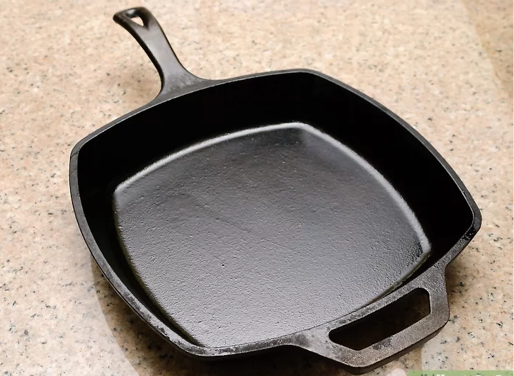

**2.Heat the pan on medium-high.**

Unless you have a non-stick pan, you should heat the pan before you add the oil. This will prevent the meats from sticking to the pan. It will also heat the oil more quickly. It will only take two or three minutes for the pan to heat up.

If you have a nonstick pan, add the oil to a cold pan and heat both up together.

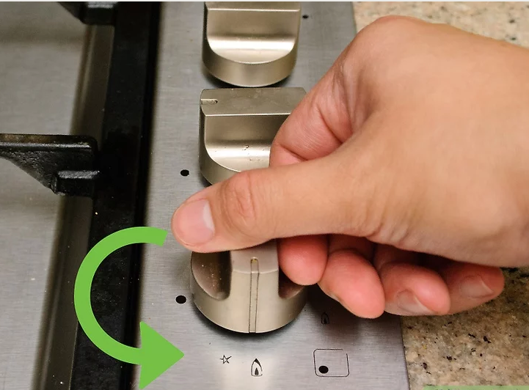

**3.Add cooking oil.**

One or two tablespoons is enough. Tilt the pan to evenly spread the oil over the surface. The best oils to use are flavorless. These include light or refined olive oil, canola oil, and peanut oil. Avoid using extra-virgin olive oil (EVOO) if possible.

EVOO can burn in the pan when frying because of its lower smoke point. EVOO starts to smoke at 325-375F compared to 465F for light or refined olive oil. Since food starts to fry around 365-375F, your extra-virgin olive oil may begin to burn before it starts to fry, giving your food a bitter taste. If you have no other option, watch the oil carefully. If it starts to smoke, remove from the heat and let it cool before dumping it and trying again.

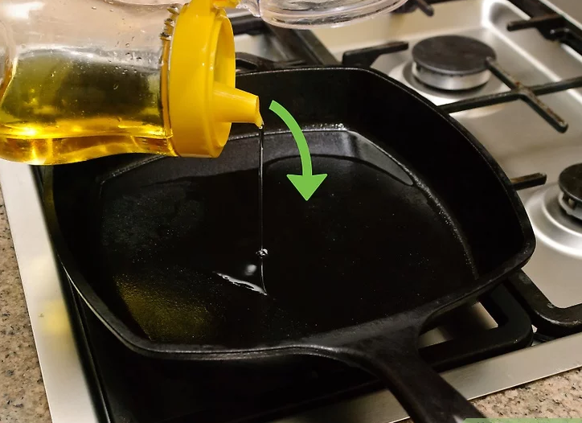

**4.Wait for your oil to heat.**

If you added the oil to a hot pan, it should heat up quickly—within a minute of adding it. If you added oil to a cold pan, it may take a few minutes for it to heat up. There are a few tests you can do to see if it is hot enough.

Use a cooking thermometer to know the exact heat. Stick the metal end into the oil, and wait 5 seconds for an accurate reading. The oil should be hot enough around 365 degrees F.

Stick the handle of a wooden spoon in it. Bubbles will rise and pop when it is hot.

If you don’t have a wooden spoon, try a drop of water instead (and no more than a drop). The water will begin to sizzle and pop when the oil is hot enough. This may cause the oil to splatter so be careful.

Do not leave your pan unattended while heating it at the stove. It only takes a few minutes for it to heat up, and you do not want to burn the oil or start a fire.

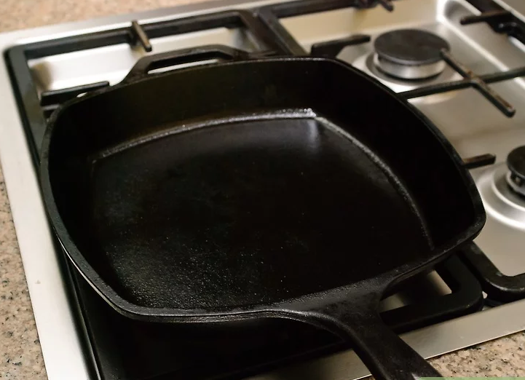

**5.Add your ingredients to the hot oil.**

Make sure that every piece has plenty of room. No two pieces of meat should be touching. Leave a small space between each. If you are cooking vegetables, make sure that there is a single layer of veggies; they should not be piled on one another. Food releases steam as it is fried. If you overcrowd the pan, the steam will not release, and you may end up with a soggy meal.

Understand that whatever side goes down first will look the best so if you are aiming for a nice presentation, put your chicken breasts down on the rounded side and your fish flesh side down instead of skin side.

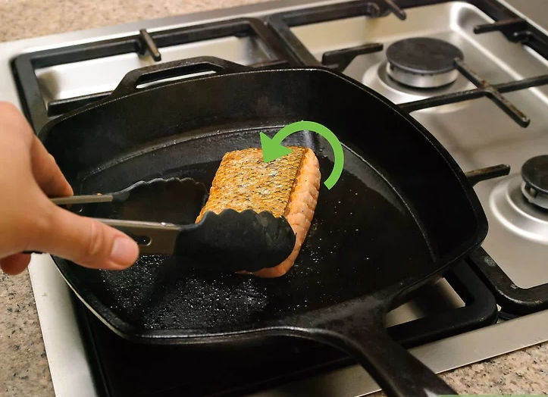

**6.Flip the meat halfway through.**

If possible, use tongs instead of a fork. A fork can puncture the meat and lose its juices. Different meats take different lengths of time. You will have to time yours based on the size of each cut and the type of meat. Flipping the meat too often or too soon can ruin the batter.

Flip chicken and steak after 4-6 minutes.

Flip fish and pork after 3-4 minutes.

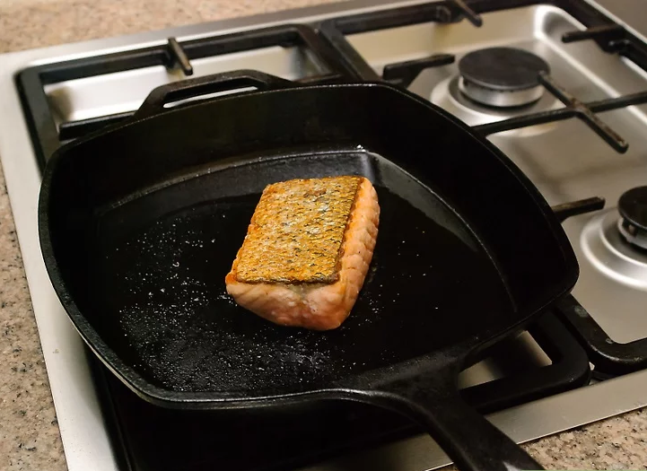

**7.Cook to your desired doneness.**

You may want to use a thermometer to make sure that the meat is fully cooked through. Stick the thermometer in the thickest part of the meat. Otherwise, you can cut open the meat to see if it is done or not. Different types of meats require different temperatures for safe eating.

Beef steaks need an internal temperature of 145 degrees F. The inside can be pink, but not red.

Chicken and turkey need internal temperatures of 165 degrees F. The inside should be white, not pink. Juices should run clear.

Pork should have an internal temperature of 145 degrees F. The inside should be mostly cooked white or brown, although there may be a slight pink tint.

Fish should have an internal temperature of 145 degrees F. The flesh should flake away easily with a fork.

**8.Remove from pan.**

Use tongs if possible. A spatula is a good back up. Place the food on a plate. If you are frying meats such as pork or beef, you may want to let the meat rest for three minutes to keep its juices intact and to let it finish cooking. Serve immediately.